URI ETAC Meeting Notes

March, 2025

____________________________________________________________________________

# Notes:

1. New Content Experience
   1. The team discussed the upcoming roll out of the Brightspace New Content Experience.
   2. Two vendor resources can be referenced for more detailed information
      1. <https://community.d2l.com/brightspace/kb/articles/3300-about-content#video-new-content-experience-lessons-overview>
      2. <https://community.d2l.com/brightspace/kb/articles/18126-content-experiences#visual-tour-new-content-experience-lessons>
2. LTI Integrations
   1. Pressbooks approved
   2. Caduceus approved
3. TLS Tech Day 2025
   1. Date: August 21, 2025
   2. Title: AI in the Classroom: Discover and Leverage URI Ed Tech Tools
4. It was suggested that ETAC collaborate with Academic leadership about security reviews for technology that is used in the classroom.
   1. This will be explored during the next academic year.

# Upcoming Events:

AI Big Data Forum

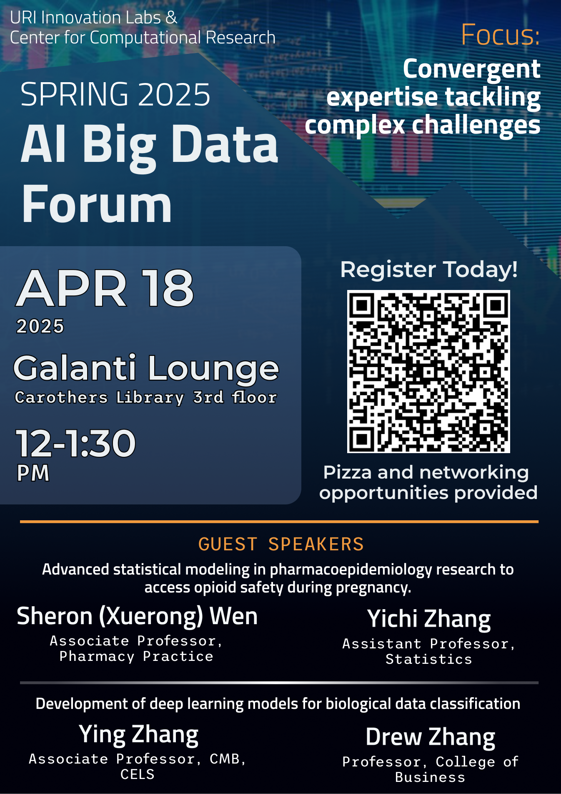

AI in Industry Forum

