URI ETAC Meeting Notes
March, 2025
____________________________________________________________________________

Notes:
- New Content Experience
  - The team discussed the upcoming roll out of the Brightspace New Content Experience.
  - Two vendor resources can be referenced for more detailed information
    - https://community.d2l.com/brightspace/kb/articles/3300-about-content#video-new-content-experience-lessons-overview
    - https://community.d2l.com/brightspace/kb/articles/18126-content-experiences#visual-tour-new-content-experience-lessons
- LTI Integrations
  - Pressbooks approved
  - Caduceus approved
- TLS Tech Day 2025
  - Date: August 21, 2025
  - Title: AI in the Classroom: Discover and Leverage URI Ed Tech Tools
- It was suggested that ETAC collaborate with Academic leadership about security reviews for technology that is used in the classroom.
  - This will be explored during the next academic year.

Upcoming Events:
AI Big Data Forum
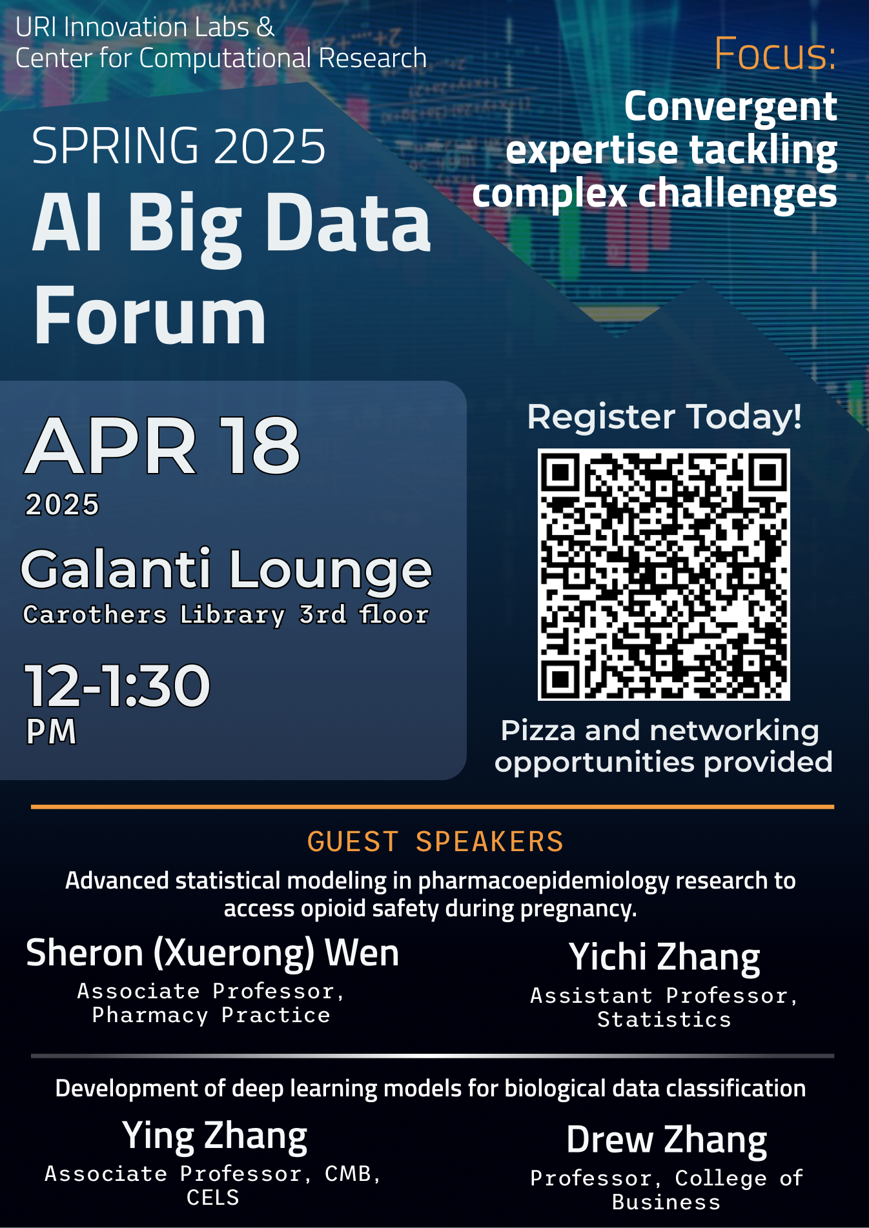

AI in Industry Forum
